

COURSE: (CL-1004) OBJECT ORIENTED PROGRAMMING LAB

LAB TASK # 3 WEIGHTAGE: 2

**NOTE:**

Only submit .cpp file of each question in a folder. Anyone who submits any other format file will get straight **ZERO.** Each question should have a separate .cpp file. Copy Paste or other UFM will also get **ZERO**. Use the following format for naming the folder Roll#_Name (P18-1234_NAME).

**Q No.01: Problem (Statement)**

Develop a calculator which is able to handle two numbers. The calculator can perform addition, subtraction, multiplication, and division.

**Q No.01: Problem (Analysis)**

* Ask the user to enter two numbers
* Then ask to enter the operator (+, -, /, *)
* Calculate the result
* Display the result

Note: use if else-if else statement for solving this problem.

**Problem (Output)**

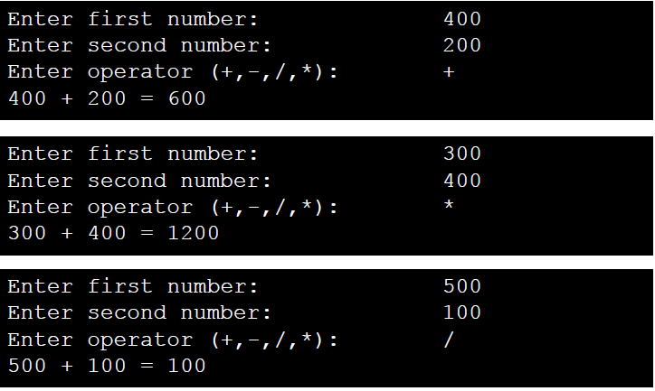

**Q No.02: Problem (Statement)**

Develop a calculator which is able to handle two numbers. The calculator can perform addition, subtraction, multiplication, and division.

**Q No.02: Problem (Analysis)**

* Ask the user to enter two numbers
* Then ask to enter the operator (+, -, /, *)
* Calculate the result
* Display the result

Note: use switch statement for solving this problem.

**Problem (Output)**



**Q No.03: Problem –3 (Statement)**

Write a program that takes grade as an input from the user and depending upon the grade display the message. Following is the criteria:

* If grade is 'A' then display “Excellent”
* If grade is 'B' then display “Very Good”
* If grade is 'C' then display “Good”
* If grade is 'D' then display “Poor”
* If grade is 'F' then display “Fail”

Note: use switch statement for solving this problem.

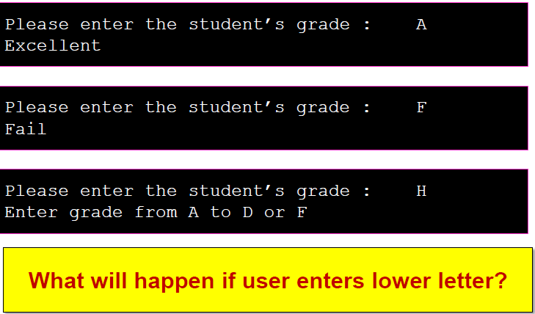**QNo.03: Problem –3 (Output)**

**QNo.04: Problem –4 (Output)**

Write a program that takes grade as an input from the user and depending upon the grade display the message. Following is the criteria:

* If grade is 'A' or 'a' then display “Excellent”
* If grade is 'B' or 'b' then display “Very Good”
* If grade is 'C' or 'c' then display “Good”
* If grade is 'D' or 'd' then display “Poor”
* If grade is 'F' or 'f' then display “Fail”

Note: use switch statement for solving this problem.

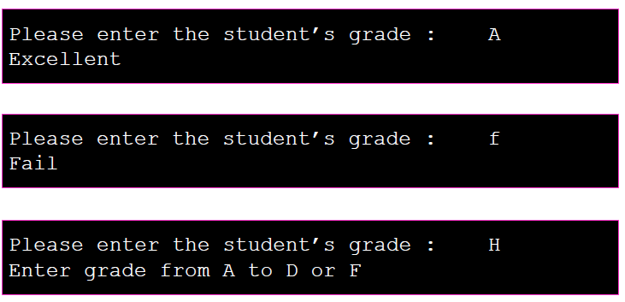**Q No.04: Problem –4 (Output)**

**Q No.05: Problem –5 (Statement)**

In a company, there are deductions from the salary of the employees for a fund. The deductions rules are as follows:

* If salary is less than Rs.10,000 then no deduction
* If salary is equal to or more than Rs.10,000 and less than Rs.20,000 then deduct Rs.1,000 as fund
* If salary is equal to or more than 20,000 then deduct 7 % of the salary for fund
* Input salary from user and after appropriate deduction show the net payable amount.